**Use Case 1: Write down a note**

User can type in any notes in the upper half of the EditText:

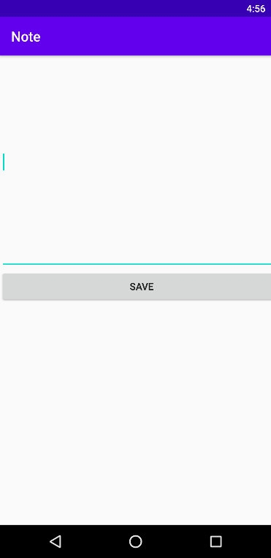

After entering the notes, user could simply click on the SAVE button.



The notes will be saved in the half bottom of screen which is the listView part.

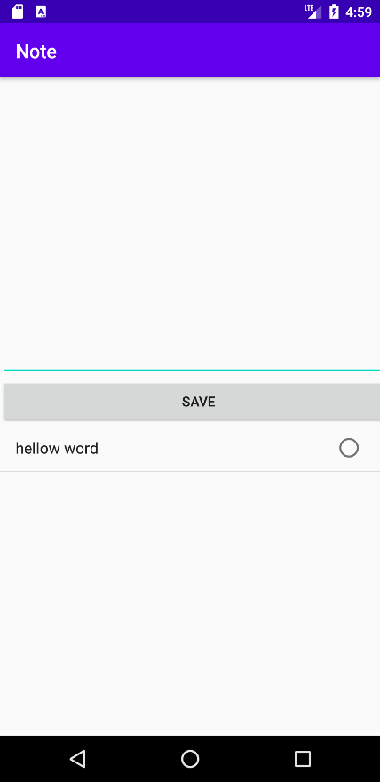

**Use Case 2: Edit an existing note**

User can edit the existing note by clicking the note from lower half of screen (the listView):



After selecting the notes, the notes will show up in the upper half of screen:

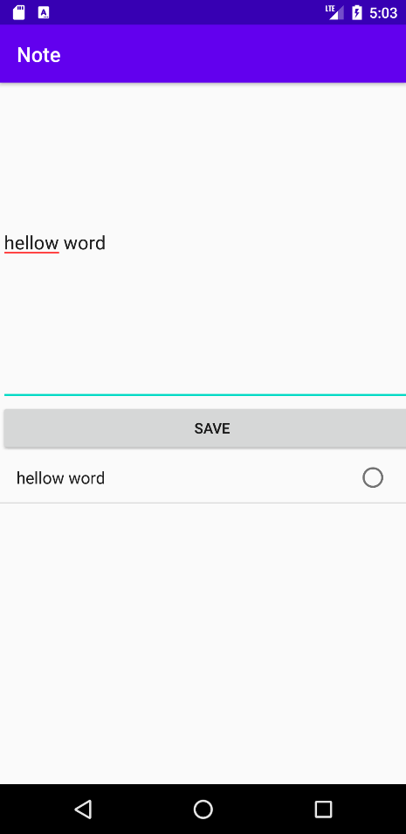

User can edit the notes in upper half of the screen and then click save:

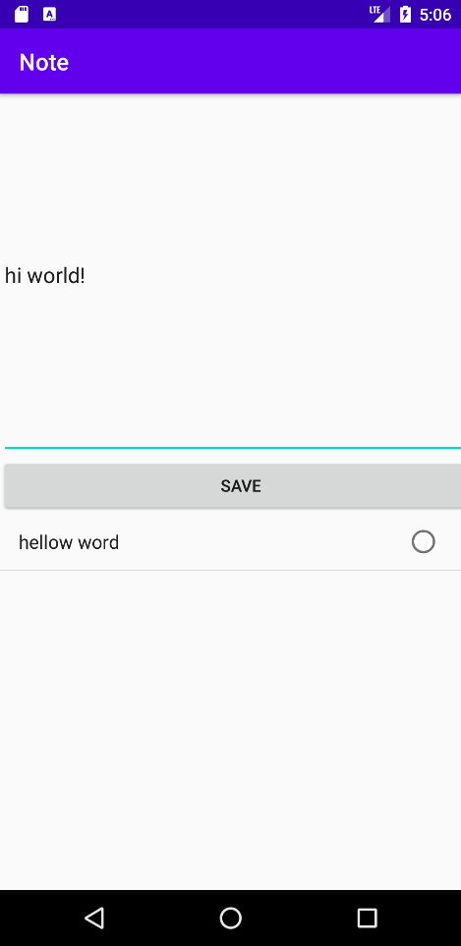

The note will be changed and saved to the bottom of listView:

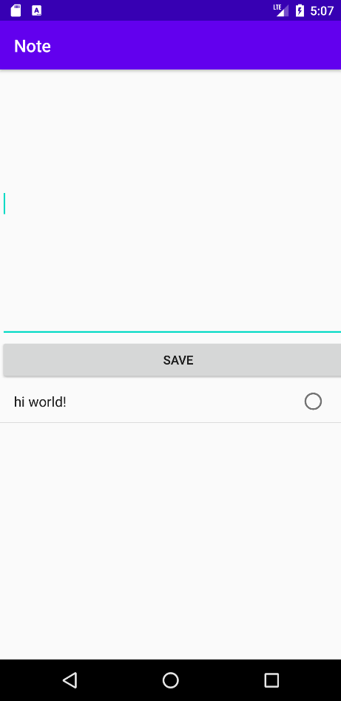s